|  |  |
| --- | --- |
| PROPOSED TRANSACTION:  Purchase of Project Saint – Healthcare Facility in Tokyo, Japan | ON BEHALF OF CLIENT:  Savills IM Asia Pacific Income & Growth Fund (“APACIG”) |

**“Project Saint” – St Catherine’s Hospital, Tokyo**

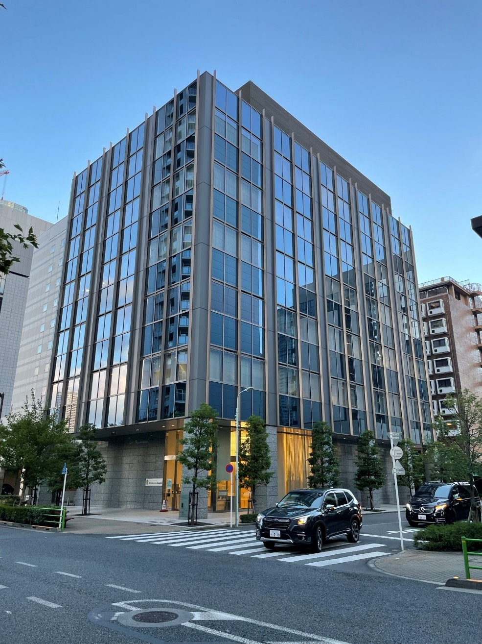

**Stage 1:**

Date of Issue: 1 September 2023, Version 1

Date of SIM IC meeting: 5 September 2023

1. Transaction Investment Proposal
   1. Executive Summary

|  |  |
| --- | --- |
| Client Name | *Savills IM Asia Pacific Income and Growth Fund (“APACIG”)*  *Sub Fund A* |
| Relationship to Client | *Discretionary fund management agreement*  *Investment Advisor of APACIG* |
| Client Strategy | *The Fund seeks to construct a portfolio of Real Estate assets across the major cities in Asia Pacific region providing:*   * *Resilient income return* * *Potential for growth* * *Diversity (across countries, markets, sectors and assets)*   *Targeting net Fund IRR of 8%-10% and an average net distribution of 4.0 % p.a.* |
| Further steps/Approvals required | *Approval of the Savills Investment Management (Luxembourg) Sarl (the “Management Company”)* |
| Transaction Type | *Acquisition* |
| Description of proposed transaction | *Off-market negotiation direct with seller, Sumitomo Realty & Development, for modern healthcare asset located in the Harumi submarket of Chuo Ward, central Tokyo.*  *The 6-storey asset was completed in 2017 and comprises 3,497 sqm of floorspace 100% leased on a 20-year fixed-term lease until 2037 to St Catherine’s Hospital, a rehabilitation hospital that provides recovery medical care, support for independent living, while also serving as a local home doctor. The site is zoned for healthcare/medical use in the Chuo Ward masterplan.*  *St Catherine’s Hospital (established in its current form in 2006) works in collaboration with nearby St Luke’s International Hospital (founded 1901) and other acute care institutions. St Luke’s Foundation, the NPO affiliate to St Luke’s International Hospital, acts as the master-lease guarantor for St. Catherine’s Hospital.*  *Harumi is a popular bay-side area and regeneration zone. It is home to numerous office and commercial facilities, with a population of c.19,000 residents and a catchment of c.78,000 residents across c.40,000 households in the surrounding Tsukishima district. Its population has been growing rapidly over recent decades with numerous high-rise condominium towers developed by groups such as Mitsui Fudosan, Mitsubishi Estate and Sumitomo Realty.*  *The population is set to expand further with the impending opening of Harumi Flag, the former Olympic Village complex with some 4,000 residential units for sale in phases. We anticipate these positive local demographics to support demand for St Catherine’s Hospital, both its specialist rehabilitation services and function as a walk-in medical clinic.*  *Based on current negotiations with the seller, the deal is expected to be contracted around end-December and close in April 2024.* |
| Sustainability Attributes | * ***Climate Action*** *– the asset poses limited flooding risk and has up to standard earthquake resistance. Sustainability features are embedded such as LED lighting, water-efficient toilets, and others. Further ESG improvements can be considered where applicable.* * ***People*** *– asset provides access within walkable distance to a metro station and numerous bus routes, as well as residential districts and various amenities such as F&B, office/commercial complexes, etc. The hospital’s function as a clinic is a service for the local catchment area.*      * ***Nature*** *– there are trees and greenery surrounding the asset, with opportunities to enhance greenery to be further explored as space permits* |
| Proposed Structure of Transaction | *Acquisition of trust beneficiary interests in the subject real estate via a TMK/GK-TK structure, at a withholding tax rate of c.13%. Under this structure, only nominal registration tax is payable with zero acquisition tax.*  *The asset will be 100% owned by the Fund and the structure will be compliant with the German Real Estate Quota.*  *Subject to lender discussions, the asset may be added to APAC2 TMK financed by Aozora Bank, which would provide operational cost savings (currently not included in base-case)* |
| Financial Information | *Purchase Price: JPY 3.30 billion*  *Gross Purchase Price: JPY 3.48 billion*  *Net Initial Yield (NOI/GPP) – in-place: 4.40%*  ***Net Income Yield (NOI/NPP) – in-place: 4.64%***  *Asset level distribution (levered, post tax, pre-fees): 6.56%*  *Asset level IRR (levered, post tax, pre-fees): 14.2%*  *Fund level distribution (levered, post tax, post-fees): 5.45%*  *Fund level IRR (levered, post tax, post-fees): 13.1%* |
| Rationale | *The property fits well within the APACIG Fund’s target asset profile given:*   * *High-quality healthcare asset in an established commercial and residential district of central Tokyo* * *Attractive income yield supported by long-term master-lease with credit guarantor.* * *Provides diversification from other uses in the Fund portfolio; non-discretionary sector in a submarket that is undergoing ongoing regeneration and population growth.* * *Off-market negotiation direct with seller at negotiated pricing.* * *Our direct approach allows the mutual benefit of zero brokerage fees for the seller and minimized brokerage fee for the buyer (the Fund m*ay *pay a minimized brokerage fee of c. 1% to facilitate the sale)* |
| Asset Strategy | *Upon acquisition, the management strategy would be focused on maintaining strong tenant relations and optimizing Building Management processes.*  *Property management: A top-tier PM company will be appointed as PM with a limited scope due to the master-lease, such as to manage maintenance and tenant relations.*  *Asset management: Savills IM will have full asset management responsibility.*  *Hold strategy: 4-year hold period assumed, which would potentially allow for re-investment mid-way through the fund life. Investigate potential improvement in the ESG qualities in collaboration with the master-lessee, with a focus on monitoring of energy and water usage.*  *Exit strategy: Target buyers would be major domestic and international investors including J-REITs, motivated local companies as well as private investors. The asset will enjoy a high level of liquidity at exit due to its strong location, quality and mid-scale lot size. A targeted sales process would be conducted to identify the most motivated buyers at that time.* |
| Significant Risks and Mitigations | *Tenant credit risk: the property is fully occupied on a long-term master-lease. Credit risk is mitigated by a rental guarantee from St Luke’s Foundation.*  *In the worst-case scenario, the property could be re-leased to another hospital operator or repositioned as a multi-tenant property focusing on clinics and office tenants, with limited capex requirement for conversion.*  *Exit liquidity risk: is mitigated by a) the discounted entry price and benchmarking of exit pricing to current market price points, b) the depth of the buyer market for mid-sized healthcare/commercial assets, c) the quality of the building and location.*  *Inflation risk: Forecasts indicate that current inflationary pressures are cost-driven and likely to be transitory. Nonetheless, the lease term allows for rent reviews every 5 years on a negotiated basis, which could support modest rental upside albeit not assumed in our base-case.* |
| Priority Issues for Due Diligence | * *PML* * *Capex* * *Building code compliance* * *Tenant credit risk* |
| Conflicts of Interest | *The Transaction Sponsor and Fund team confirms no conflict of interests.* |
| Recommendation | *The Transaction Sponsor requests a recommendation to the Management Company that:*   1. *All due diligence expenditures including legal and entity setup expenditures associated with the transaction be authorized.* 2. *A second due diligence report covering any outstanding items will be issued to the IC with a request for a final recommendation. This will include due diligence items, the final deal structure, final debt terms and any resulting adjustment to the project underwriting or other material changes.* 3. *Upon satisfactory completion of due diligence and subject to any conditions precedent, a binding purchase contract for Project Saint will be executed at a purchase price of JPY 3.3 billion around December-end 2023. It will be entered into by a newly established shell SPC under the base-case assumption.* 4. *The acquisition will be completed around April-end 2024.* |

* 1. Key information

|  |  |
| --- | --- |
| Name/Address of Property | *Project Saint / St Catherine’s Hospital*  *3-7-10 Harumi, Chuo-ku, Tokyo 104-0053* |
| Sector | *Healthcare* |
| Net lettable area and Car Parking | *3,033.79 sqm (NRA per master-lease contract)*  *10 car parking (mechanical)* |
| Major tenants, and lease expiry / break dates | *St Catherine’s Hospital (100%)*  *Lease term: 20 Fixed-term lease without break option (Nov-16-2017 to Nov-15-2037)*  *Rent guarantee agreement in place with St Luke’s Foundation for duration of the lease.* |
| Tenure/Interest | *Freehold* |
| Vendor/Counterparty | *Sumitomo Realty & Development Co., Ltd.* |
| Counterparty Full Legal Name | *As above.* |
| Agent of Counterparty | *N/A.* |
| Transaction Sponsor | *Greg Lapham – Fund Manager* |
| Transaction Manager | *Takaaki Watanabe, Will Johnson* |
| Date of this paper/version number | *1 September // version 1* |
| Net Purchase Price (NPP) | *3,300,000,000* |
| Estimated Purchase Costs | *179,447,783* |
| Estimated Gross Purchase Cost (GPP) | *3,479,447,783* |
| Gross Rental Income (GRI) | *176,400,588* |
| Estimated Net Rental Income (NOI) | *152,979,995* |
| Estimated Gross Rental Value (GRV) | *176,400,588* |
| Estimated Net Rental Value (NRV) | *152,979,995* |
| Gross Initial Yield (GRI/GPP) | *5.07%* |
| Net Income Yield (NOI/NPP) | *4.64%* |
| Net Initial Yield (NOI/GPP) | *4.40%* |
| First year Fund level dividend yield | *5.38%* |
| Average Fund level dividend yield (4 yrs) | *5.45%* |
| Asset Level IRR (un-geared) | *7.60%* |
| Project Level IRR (geared, post tax) | *14.2% (pre-fees)* |
| Fund Level IRR (geared, post tax) | *13.1% (post fees)* |
| Proposed professional team for Client |  |
| Investment Agent | *Mizuho Trust Bank (TBC – assumed broker for legal process purposes)* |
| Legal Adviser | *Greenburg Traurig* |
| Tax Adviser | *KPMG Tax* |
| Technical/Building Surveyor | *Tokio Marine & Nichido Risk Consulting* |
| Environmental Consultant | *Tokio Marine & Nichido Risk Consulting* |
| Independent and/or Bank Valuer | *LCR or other approved valuer* |



Seeking approval of JPY15,895,000 to conduct due diligence excluding closing costs of est. JPY14,515,000. The Fund to seek approval for closing costs post-DD at Stage 2 IC.

* 1. Background to transaction

*Off market and exclusive negotiation with the seller – top-tier listed developer Sumitomo Realty & Development, the original developer of the property.*

*This property was originally developed by Sumitomo in 2017, which coordinated its construction and pre-leasing with Chuo Ward, which introduced St Luke’s International Hospital to realize this element of Harumi’s regeneration masterplan assigned for healthcare/medical facility use.  Sumitomo has also developed multiple high-rise condo developments in the vicinity.*

*Sumitomo is seeking to trade out of non-strategic office and commercial assets held on balance sheet to recycle equity into new development projects amid rising construction and land prices. As per the Nishi Gotanda asset, the SIM Tokyo team’s relationship with Sumitomo has enabled the Fund to negotiate directly, with Sumitomo seeking a reliable exit partner that will work on its timeline for the transaction.*

*This would be the sixth property originated from Sumitomo following Nishi Gotanda under APACIG, Omori and Toyocho under GTOF and Kiba and Kudan under the Varde program.*

*Additionally, our direct approach allows the mutual benefit of zero brokerage fees for the seller and minimized brokerage fee for the buyer (to facilitate the sale), fulfilling the regulatory requirement to include a licensed brokerage company in the transaction process.*

* 1. Location

*The property is located on a corner site in Harumi, Chuo Ward in central Tokyo.*

*Harumi is an area spreading out to the south of the Kachidoki and Tsukishima areas, which has transitioned from a predominantly industrial area to an attractive commercial and residential submarket with good access to prime areas such as Ginza, Toranomon and Tokyo Station. In 1998 “Harumi Island Triton Square”–a high-rise office, commercial, and residential complex–was built in 1-chome, Harumi. Since then, the area has gone through significant redevelopment with high-rise condominium towers and mid to large-scale office developed by groups such as Mitsui Fudosan, Mitsubishi Estate and Sumitomo Realty, rapidly improving the area’s living environment and establishing a new commercial district.*

*Currently, a development project named “HARUMI FLAG” is in progress on a piece of 13 hectare land in the western part of 5-chome, Harumi. It was used as the athlete’s village for the 2020 Tokyo Olympic Games and is now entering its final phase of construction with over 4,000 residential units to be released via condo sales in phases.* *According to the government, the site is expected to be inhabited by some 12,000 new residents.*

*Harumi has a resident population of c.19,000 residents and a catchment of c.78,000 residents across c.40,000 households in the surrounding Tsukishima Area (defined as Harumi, Tsukishima, Kachidoki, Toyomicho and Tsukuda). Its population has been growing rapidly over recent decades. Harumi has gained around 12,000 residents since 2010 (c.14% annualized growth) while the Tsukishima Area and Chuo Ward have posted c.4% annualized population growth. Local government forecasts estimate that the Tsukishima Area will see its population rise to around 101,000 by 2025 and 114,000 by 2029. See Appendix deck for population charts.*

*In terms of access, Harumi is served by Kachidoki Station on the Toei Oedo Line (around 9 mins walk from the subject property). There are also multiple bus routes into Tokyo and surrounding commercial and residential neighbourhoods (i.e. Ginza, Yurakucho, Tokyo Station, Kinshicho, Yotsuya and Toyosu). Most recently, the Tokyo BRT (Bus Rapid Transit) was launched ahead of the Tokyo Olympics to serve the new Harumi Flag development, connecting Harumi with Toranomon Hills, Shinbashi, Toyosu and Ariake.*

*Looking further ahead, the Tokyo Metropolitan Government announced in 2022 a draft plan to build a new 6-km subway line connecting Tokyo Station and Ariake with seven stations, including a new ‘Harumi Station’. Construction is suggested to begin around 2030 and complete in the 2040s; however, confirmation of this plan is yet to be announced.*

*Image 1: Map of subject property & Oedo Line / BRT Line*

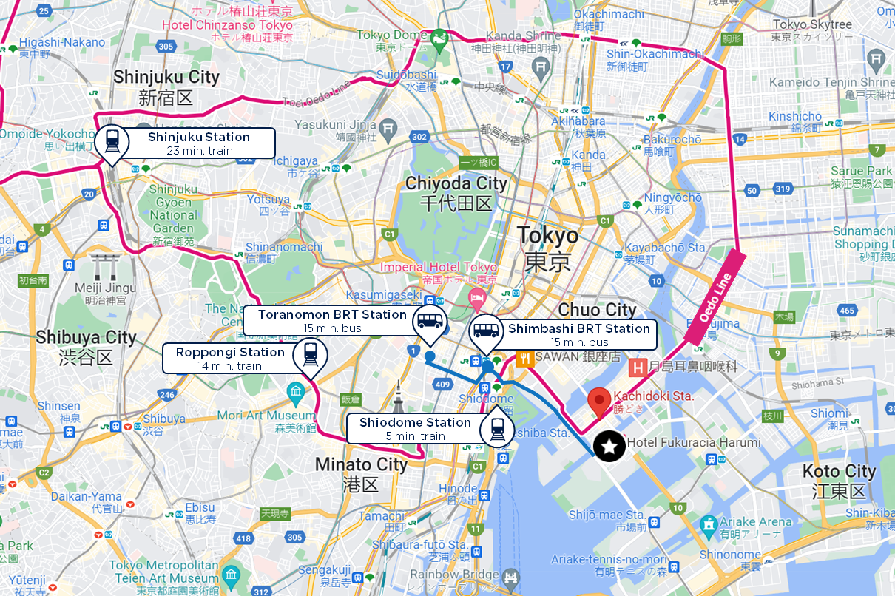

*Image 2: Map of subject property & nearby metro stations*

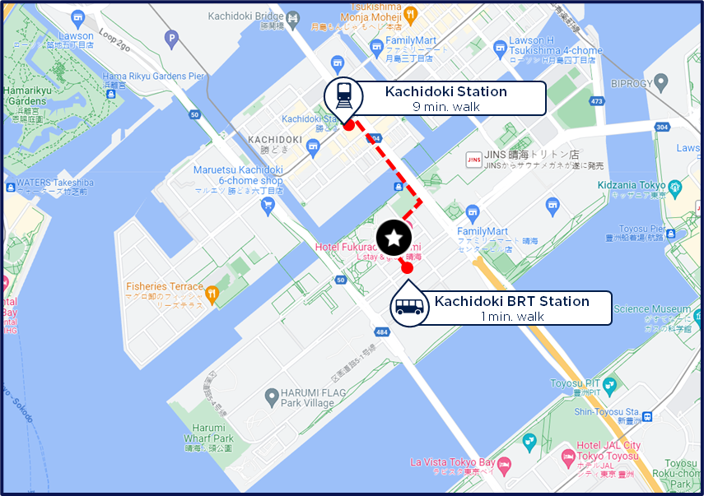

*Image 3: Aerial image of micro-location and site outline*

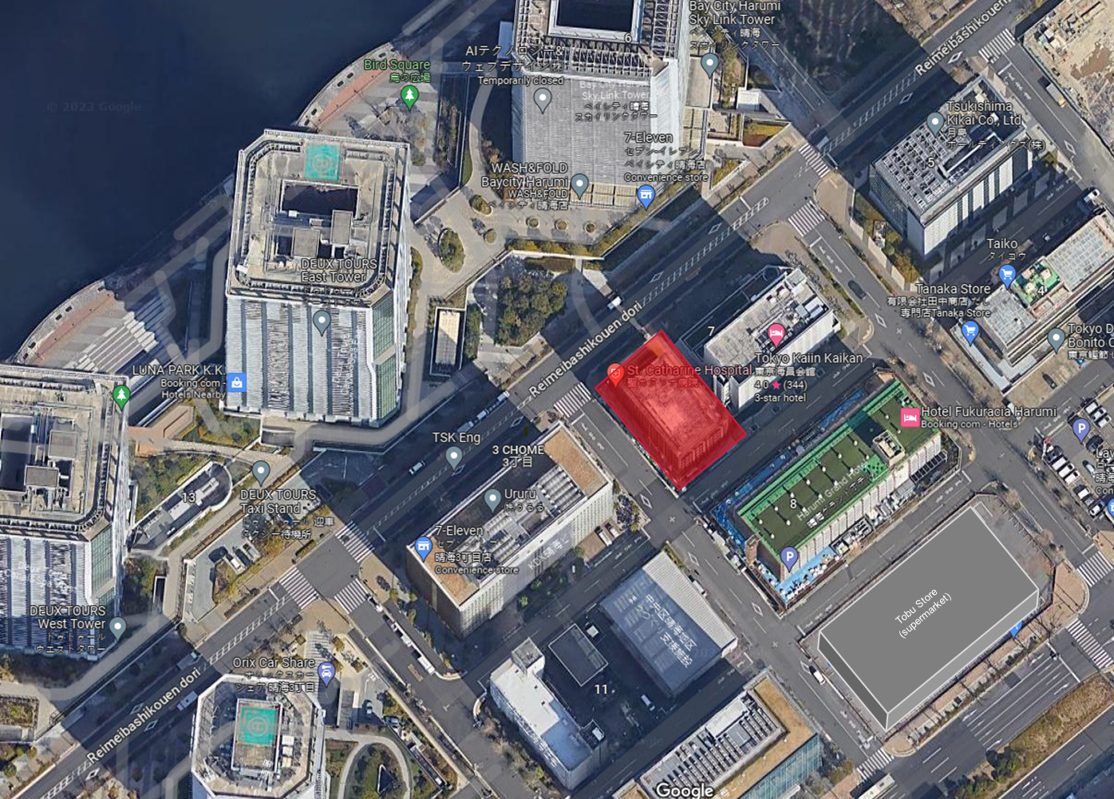

* 1. Property Description

|  |  |
| --- | --- |
|  | *Project Saint* |
| **Sector** | *Healthcare* |
| **Gross Floor Area** | 1,058 tsubo / 3,497 sqm |
| **Net Rentable Area** | 918 tsubo / 3,034 sqm (per master-lease)  809 tsubo / 2,674 sqm (multi-tenant basis) |
| **Parking Units** | 10 car (mechanical) |
| **Completion** | Nov. 2017 |
| **Stories** | 6F / B1F |
| **Structure** | SRC |
| **Standard Floor Height** | 2,700mm + 100mm raised OA flooring |
| **Standard Floor Area** | Listed in Section 1.8 |
| **Subject Rent** | Listed in Section 1.8 |
| **Land Area** | 221 tsubo / 731 sqm |
| **Tenure** | Freehold |
| **Emergency Backup Generator** | Installed on building roof  *(duration and coverage details to be confirmed during due diligence)* |

* 1. Site Environmental

*Preliminary diligence materials provided by the seller uncovered no problematic issues with the land or building plans. We will commission a full Engineering Report from our preferred consultant and will present any material changes to the IC in the due diligence report.*

* 1. ESG & Sustainability Attributes

### Investment critical

*The asset is designed and constructed in line with the most recent and stringent standards by a major developer. Upon due diligence of the property, the engineering reports will confirm compliance with local and national environmental and sustainability legislation as well as hazard risk assessment. Conclusions from the Engineering report, ESG checklist and consultation with the PM and GRESB consultant will be used to identify possible sustainability improvements and related costs versus benefits of such initiatives.*

* + 1. *Inherent physical climate and natural catastrophe risk*

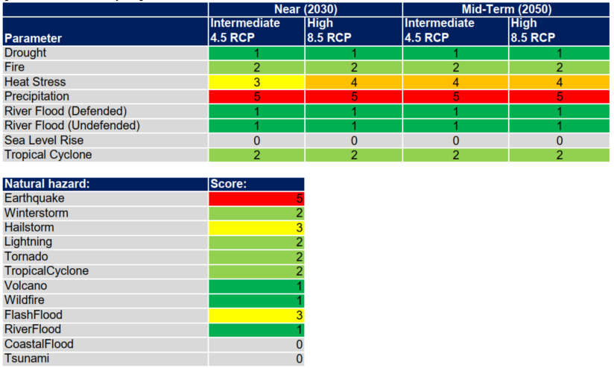

|  |  |
| --- | --- |
| **QUESTION** | **EXPLANATION** |
| **Have inherent physical climate and natural hazard exposures been identified?** | *Refer to physical climate risks and mitigants as outlined below.* |
| **Are any exposures rated 3 – 5?** | *Seismic Risk*  *Japan is a seismically active country and has some of the most rigorous earthquake building standards in the world. Although building codes are updated regularly, a major change to the building standards act occurred in 1981: all buildings built to the new earthquake code (“shin-taishin”) are designed to withstand magnitude 7 or higher. The asset, being completed in 2017, has up to standard level earthquake resistance and is compliant with the new code.*  *Precipitation & Tropical Cyclone*  *Japan experiences heavy precipitation and tropical cyclones during its typhoon season ranging from May to October, peaking in August and September. Based on analysis of Japanese government issued water hazard maps in extreme rainfall, typhoon, or tsunami scenarios, the area has been identified in the Chuo-ward’s hazard maps as a low flood risk zone and poses a low flood risk.*  *Japan’s Building Standards Act also incorporates structural safety standards to resist the strong winds of typhoons under worst-case scenarios and the possibility of landslides when planning for construction on a slope.*  *The asset complies with building regulations designed to ensure resilience to typhoon-force winds and rain.*  *The asset is also constructed to a high-standard with reinforced concrete, mitigating risk of significant structural damage to the building or harm to the tenants.*  *Heat Stress*  *Climate change in Japan, as in other areas around the world is a risk. There is a risk of an increase in temperature on hot days throughout the year, resulting in an increased demand for cooling. The following asset level measures are taken to minimize heat stress risk:*   * *Designed to optimize sustainable cooling mechanisms such as natural ventilation to reduce air conditioning load* * *High thermal insulation exterior wall and roof* * *High efficiency inverter air conditioning meeting government energy-saving standards* * *Building management systems focused on heat gain control and heat dissipation within the building to improve indoor thermal comfort with low energy consumption, reduce internal humidity and reduce the heat island effect.* |
| **Other comments** | *Findings from the engineering report during due diligence to be discussed in Stage 2 memo.* |

* + 1. *Energy rating(s)/ benchmark*

|  |  |
| --- | --- |
| **QUESTION** | **EXPLANATION** |
| Provide a list of EPC ratings or equivalent. Identify if these are only covering a portion of the building. | EPC or other similar energy efficiency credentials are not market practice and unavailable for the assets.  However, we anticipate for the energy performance for the asset to be high, given it is a modern asset completed to a high-quality suitable for a hospital tenant by a major, reputable developer. The design includes sustainability features such as energy efficient air conditioning, LED lighting and water-saving toilets.  The assets represent an attractive opportunity to enhance the sustainability profile of the Fund portfolio. |

* + 1. *Additional Sustainability Considerations*

Use this space to comment on any other relevant environmental or social sustainability points.

|  |
| --- |
| **Comment** |
| *Green Building Certification*  *Appropriate sustainability benchmarks for the Fund will also be under consideration going forward, including Fund-level GRESB participation, Green Building Rating certifications, and other relevant sustainability certifications where applicable.*  *Social & Community*  *The hospital serves as a multi-purpose medical facility, ranging from rehabilitation to general medicine, and should provide a positive community impact to the local and wider population.*  *Occupier Sustainability*  *The existing lease does not include a green lease clause, which is not market practice in Japan. However, we plan to discuss with the tenant to include a green lease clause or share its utilities data, in return enhancing its CSR credentials.* |

* 1. Lease Particulars
* *Lease term: 20 Fixed-term lease without break option (Nov-16-2017 to Nov-15-2037)*
* *Rent: JPY14,209,622/month (JPY15,500/tsubo GFA)*
* *Lease Area: 3,034 sqm*
* *Building management (BM): Tenant is responsible for most BM fees, most repairs, most cleaning and all utility costs i.e. lighting, air conditioning, other electrical costs, water, etc. Landlord is responsible for electrical supply equipment, automatic door maintenance, storage battery maintenance, fire protection equipment maintenance, water supply and drainage maintenance, planting/greenery maintenance and mechanical parking structure maintenance); this is conservatively underwritten as c.22% of total OPEX.*
* *Security Deposit: 12 months’ rent (JPY170,515,000)*
* *Rental revision clause (every 5 years) – negotiation basis; subject to mutual agreement by tenant and landlord*
* *Full rental guarantee by St. Luke’s Foundation (see Section 2.2 for Tenant Credit Risk analysis).*
* *Green lease clauses: the lease does not include a green lease clause; however, we expect that the tenant would be cooperative regarding monitoring of energy and utility usage and costs.*

*St Catherine’s Hospital usage by floor:*

|  |  |  |  |
| --- | --- | --- | --- |
| **6F** | **517.39 sqm /**  **156.51 tsubo** | **病棟 / ward** | 個室×11、スタッフステーション、デイルーム、器材庫  11 private rooms, staff station, day room, equipment storage |
| **5F** | **517.39 sqm /**  **156.51 tsubo** | **病棟 / ward** | 4床室×2、個室×6、スタッフステーション、デイルーム、器材庫  4-bed room x 2, private room x 6, staff station, day room, equipment storage |
| **4F** | **517.39 sqm /**  **156.51 tsubo** | **病棟 / ward** | 4床室×3、個室×4、スタッフステーション、デイルーム、器材庫  4-bed room x 3, private room x 4, staff station, day room, equipment storage |
| **3F** | **517.39 sqm /**  **156.51 tsubo** | **事務室・リハビリ室・特別浴室**  **Office, rehabilitation room, special bathroom** | 事務室、リハビリ室、特別浴室、面談室、院長室、会議室、サーバ室  Office, rehabilitation room, special bathroom, interview room, director's office, conference room, server room |
| **2F** | **517.39 sqm /**  **156.51 tsubo** | **外来診察室**  **Outpatient examination room** | 診察室×7、処置室、相談支援室、一般撮影室、薬剤室、検体検査室  Consultation room × 7, treatment room, consultation support room, general radiography room, pharmacy room, specimen examination room |
| **1F** | **238.98 sqm /**  **72.29 tsubo** | **受付・会計**  **Reception / Cashier** | 総合受付、医事事務室、ごみ庫、警備室、機械式駐車場  General Reception, Medical Office, Garbage Storage, Security Office, Mechanical Parking Lot |
| **B1F** | **207.86 sqm /**  **62.87 tsubo** | **更衣室・機械室**  **Changing room/machine room** | 倉庫、更衣室2室、霊安室、機械室  Warehouse, 2 changing rooms, mortuary, machine room |
| **Total** | **3,033.79 sqm /**  **917.74 tsubo** |  |  |

* 1. Supporting Evidence
     1. *National Markets*
* *Prime Net Office Yields for Tokyo remained at 2.25% as of Q2 2023, having tightened from 2.50% in Q4 2022, according to PMA. Transaction evidence suggests that Grade B+ office assets are priced in the low-3% range.*
* *In the absence of publicly available transaction data for healthcare assets, the Japan team and sounding of third-party appraisers suggest that the yield spread for hospital-type healthcare assets is 30-70 bps higher than similar-scale Grade B+ office assets in Tokyo.*
* *The stabilized entry yield for the subject property based on the discounted purchase price is 4.64%, approximately 239 bps higher than Tokyo Prime Yield. Based on the underwritten exit NOI cap rate of 3.8%, the asset is approximately 175 bps higher than the prime benchmark yield.*
* *Given that interest rates are generally expected to remain stable at current low levels and there is continued focus among institutional investors on the core-type investments in Japan, market cap rates are expected to remain broadly stable over the short- to mid-term.*
* *Forecasts indicate that current inflationary pressures are cost-driven and likely to be transitory.*

*Chart 1: Subject deal cap rates vs. Tokyo prime office market cap rates and 10-year JGB yields, 2013-2027F*

*(%)*

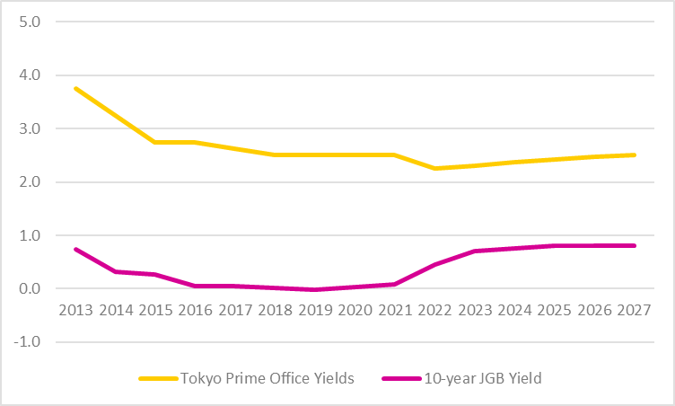

ß Exit

ß Entry

*Forecast*

*Source: PMA (Main Scenario: April 2023)*

*Chart 2: Japan inflation and target rate (%)*

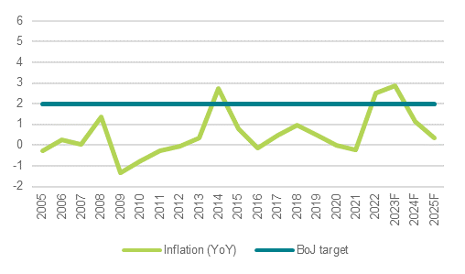

*Forecast*

*Source: Oxford Economics (22 August 2023)*

* + 1. *Investment Transactions*

*See Appendix*

* + 1. *Rental Value*

*See Appendix*

* 1. Operating costs

|  |  |  |  |
| --- | --- | --- | --- |
| ***Operating Expense*** |  | ***Yearly total*** | ***Rate*** |
| *PM Fee* | *JPY* | *-1,234,804* | *0.7% of EGI* |
| *BM Fee* | *JPY* | *-5,078,239* | *JPY400 per tsubo GFA; c.22% of total OPEX* |
| *Repairs* | *JPY* | *-3,702,883* | *0.25% of building replacement cost value (RCV)* |
| *Property Tax* | *JPY* | *-12,286,263* |  |
| *Utilities Expense* | *JPY* | *0* | *JPY0 per tsubo GFA* |
| *Insurance* | *JPY* | *-518,404* | *0.04% of RCV* |
| *Other OPEX* | *JPY* | *-600,000* |  |
| ***Total Operating Expense*** | ***JPY*** | ***-23,420,593*** |  |
|  |  |  |  |
| *CapEx* | *JPY* | *-3,702,883* | *0.25% of RCV* |
| *Trustee Fee* | *JPY* | *-1,000,000* |  |
| *Other* |  | *0* | *1.25% of EGI* |
| ***Total Non-Operating Expense*** | ***JPY*** | ***-4,702,883*** |  |

1. Risk Management
   1. Key risk considerations

|  |  |
| --- | --- |
| **RISK CATEGORY** | **EXPLANATION** |
| **MARKET RISK** | Currency Risk   * The Fund does not have any requirement to put currency hedging in place, however we would aim to follow group central policy of fully hedging this exposure. * The Fund is a EUR & USD denominated fund focusing on real estate assets in Asia Pacific * This investment will cause the Fund to have exposure to the Japanese Yen (“JPY”) * Foreign currency swaps between EUR and JPY, as well as USD and JPY, are expected to be implemented to hedge 100% of the equity for the 4-year hold period. FX hedging costs/benefits are conservatively underwritten at 0.0% p.a (4 years). Currently, 4-year FX benefit of hedging EURJPY is +3.25% p.a. (+4.00% in Y1), while USDJPY is +4.95% p.a. (+6.00% in Y1). The hedge will be traded at the Fund level.   Debt Finance Risk   * The Fund’s leverage restriction to the aggregate appraisal value (LTV) is 60% across the portfolio. * The underwritten loan to purchase price (LTP) of 65% (subject to change) is above the limit, however, due to the material discount to market value going in, the LTV is expected to be below the upper fund threshold. * We are speaking with lenders with whom we have recently transacted, including Aozora, Mizuho Trust Bank, PGIM and Credit Agricole, as well as others including Tokyo Star Bank. * Aozora Bank has a high level of motivation and has provided favourable indicative terms for this deal as an amendment to the existing debt facility for projects Yokohama-Kitasaiwai and Nishi Gotanda. * Cost efficiencies derived from utilizing a shared holding and debt structure with Project Yokohama-Kitasaiwai and Nishi Gotanda are currently not incorporated in the base-case underwriting but could provide modest upside. * Debt will be non-recourse with standard covenants and security requirements in line with previous deals in our Japan funds. * Associated execution risk is mitigated by our track record with the target lenders, the quality of the asset and relatively low LTV.   Interest Rate Risk   * Real estate investments are sensitive to interest rate risk; the hedging of interest rates, including the decision of whether to hedge, is at the discretion of the fund manager. * The debt for this transaction will likely be fixed rate, per previous Japan deals. * However, should the investment move forward with a floating rate loan, there will be a purchase obligation to buy a cap should the base rate reach the level agreed with lender.   + It is widely expected that the Japanese government will continue to maintain a low-rate environment for the foreseeable future given its own high deficit levels and aggressive stimulus policy. As such, we do not expect to purchase an interest rate cap at the acquisition timing.   + To mitigate any related risk, we will monitor market conditions and re-assess periodically during the underwritten hold period. * See Appendix for downside scenario with 30bps added to the base-case debt cost assumption. |
| **LIQUIDITY RISK** | *The primary risk to the forecast performance is exit liquidity. We consider this risk to be mitigated by:*   1. *The discounted entry price derived from the seller’s special situation, with our stabilized NOI yield c.84 bps above where the market trades today.* 2. *The depth of the buyer market for quality assets in central Tokyo from institutional investors, both domestic and international, motivated local companies and private investors/family offices.*   *- Healthcare assets are increasingly sought-after by investors seeking diversification and stable long-term non-discretionary income streams.*  *- In a re-tenanting scenario, the property can be readily converted into multi-tenant including clinics and office tenants, or leased to a single replacement healthcare tenant.*   1. *Rising land values and replacement costs, the latter driven by significant labour shortages in the construction sector.* |

* 1. Tenant Credit Risk
* *The property has St Catherine’s Hospital as the sole tenant on a fixed-term 20 Fixed-term lease without break option (Nov-16-2017 to Nov-15-2037).*
* *Credit risk specific to the tenant is mitigated by a full rent guarantee from St Luke’s Foundation for the duration of the lease.*

*Credit rating and analysis*

*According to rating agency Teikoku Databank (TBD) as of 31 July 2023:*

***St Catherine’s Hospital*** *has an overall credit score of 41/100.*

*It is categorised in the lower-mid credit tier (36-50 points), which mainly comprises small to mid-sized companies and start-up companies with weaker credit.*

*The TBD scoring system has a maximum score of 100, with most Japanese businesses falling into the 40-60 point range. As privately held companies, public credit ratings are not available.*

*Within the “Bedded Clinics” category - Ranked 51/145 within Tokyo prefecture and 832/1,391 within Japan.*

*St Catherine’s works in collaboration with St Luke’s International Hospital and was founded in 1955. It was established in its current form in 2006 and has JPY30 million in paid-in capital and 50 staff.*

*The sole representative and single shareholder with 100% ownership is an individual, Nobuyuki Komiyama. He is also the head doctor of the cardiovascular department of St. Luke’s International Hospital. Tenant CDD will be conducted as part of the DD process as well as by the trust bank during the entrustment process.*

***St Luke’s International Hospital*** *has an overall credit score of 61/100.*

*St Luke’s is categorised in the upper range of the medium tier (51-65 points), which denotes average creditability; companies with fair business foundations and overall stable management conditions.*

*St Luke is a major university hospital in Chuo-Ward, founded in 1901. It was established in its current form in 1954 and has JPY71.6 billion in paid-in capital and 2,133 staff.*

*St Luke’s Foundation, the master-lease guarantor to St. Catherine is an NPO affiliate to St Luke’s International Hospital. It does not have a TDB score due to its status as an NPO, however, records show their close affiliation to the hospital entity, with the Foundation typically active in large asset transactions. Land registry records show that ownership of the land and building of St Luke’s International Hospital was owned by St Luke’s Foundation for 20 years before being transferred to another St Luke’s affiliate in 2014. Currently, the Foundation is the landowner to St Luke’s Tower, an office and residential development neighbouring the hospital. These are valuable large tracts of centrally located land in Chuo Ward near Ginza; an inspection of the property records shows that the land is not used to secure any debt and has no liens.*

*Historical record of St Luke’s Foundation:*

* *1936 - St. Luke's International Medical Center established*
* *1943 - Name changed to Daitoa Idoin Foundation*
* *1945 - Name changed to St. Luke's International Hospital Foundation*
* *2013 - Transitioned to a general incorporated foundation and changed its name to St. Luke's International Medical Center.*
* *2014 - Transferred hospital business to St. Luke’s International University*
* *2015 - Name changed to St. Luke's Foundation*

*In addition to its credit ratings, TDB provides another index of risk management, "Bankruptcy Prediction Value".  TDB uses quantitative and qualitative data analysis methods to predict the probability that a company will go bankrupt within a year, based on the corporate information database accumulated through its own credit bureau and information coverage network. It is quantified as "predicted value" (0 to 100%) and 10 levels from G1 to G10, with G10 is the highest risk grade.*

*As of 12 August 2023, TDB’s Bankruptcy Prediction Value (BPV) for St Luke’s International Hospital was 0.04%, equating to Level G1, the lowest risk level. A BPV is not available for St Catherine’s Hospital or St Luke’s Foundation.*

*Financial information – St Catherine’s:*

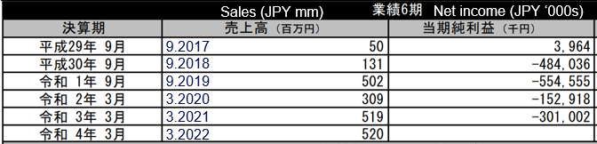

*Financial information – St Luke’s International Hospital:*

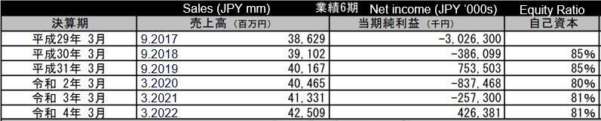

*St Luke’s financial performance was impacted in fiscal 2020 and 2021 by the pandemic, however, achieved profitability in fiscal 2022 of JPY426mn. Furthermore,* *revenue has been on a steady upward trajectory, increasing 2.9% from fiscal 2021 primarily due to a post-pandemic recovery of medical activities (i.e. hospitalizations, outpatients, surgeries, etc.). The large book loss in 2017 is an extraordinary balance sheet adjustment relating to liabilities resulting from an undisclosed asset transfer.*

*St. Catherine was also heavily impacted by the pandemic due to its function as a rehabilitation hospital and people avoiding close contact during the pandemic as well as the delayed opening of the Harumi Flag complex. We expect their business to improve particularly in the standard medical care in the post-pandemic era as well as demand from the Harumi Flag (ex-Olympic village) tenants populating the neighbouring developments.*

*As the tenant is under a fixed-term lease, they do not have the ability to terminate the lease mid-term and are liable for the remainder of the rent until expiration with St. Luke’s Foundation acting as a rental guarantor in case of default. While ability to secure rental income for an extended period from a tenant under default is challenging, we will have the ability to retain the security deposit which can be used to cover the reinstatement of the existing fit-out.*

|  |
| --- |
| **OCCUPIER EXCLUSIONS** |
| **How do the activities of the occupier meet compliance with Savills IM’s Exclusions Policy?** |
| *The occupier is not engaged in any activity which could pose a risk to compliance with our exclusions policy.* |

*Potential to re-tenant/reposition the asset (downside scenario):*

*The risk of credit default by both the tenant and its creditor is deemed limited and highly unlikely. However, the impact of such an event on the investment returns is mitigated to a large extent by the ability to re-lease or reposition the property.*

* *The property could be re-leased in its entirety to an alternative hospital tenant. St Luke’s and its guarantor are obligated to pay full reinstatement costs. Nonetheless, capex relating to reinstatement is not expected to exceed the 12-month rental deposit. Moreover, a replacement tenant may elect to retain some or all of the existing fit-out to achieve material cost savings. An alternative operator may be another St Luke’s affiliate, or an operator introduced by them, given their position as guarantor.*
* *The property could be repositioned as a multi-tenant property. The property is currently zoned under healthcare/medical use, therefore our downside assumption is that the tenant base would be predominantly clinics (i.e. a ‘medical mall’), with some office use allowable under existing zoning rules. Related capex is not expected to exceed the 12-month rental deposit. Please see Appendix for indicative downside scenario returns.*
* *Change of use to full office use may be permitted by Chuo Ward upon application. However, this is uncertain and is not an assumption within our downside scenario.* 
  1. Investor & Non Exec. Advisor issues

*Given the quality of the asset and the location, stabilized net yield in excess of 4%, as well as the attractive pricing derived from the seller’s special situation, the fund investors are expected to be supportive of the transaction.*

*There are no issues raised by this transaction in terms of fund criteria or conflicts which require Advisory Committee approval.*

1. Investment Compliance
   1. Client investment guidelines or restrictions

| ***Guideline and/or restriction*** | ***Transaction within guideline and/or restriction:***  ***Yes / No*** | ***Comments*** |
| --- | --- | --- |
| ***Sub-Fund A (Conventional)*** | | |
| *The Fund, at any time, not to invest more than 20% of GAV outside of Japan, Australia, Singapore, South Korea and Hong Kong* | *Yes* | *Investment in Japan* |
| *The Fund, at any time, shall not invest more than 20% of its GAV in China, Malaysia, Thailand, Vietnam, Indonesia and New Zealand* | *Yes* | *Investment in Japan* |
| *No Single Asset shall exceed 20% of GAV* | *Yes* | *Saint would comprise 5.3% of current GAV* |
| *The Fund, at any time (beyond investment period), shall not invest more than 55% of GAV in any one country* | *Yes* | *Investment in Japan would account for 35% of Fund GAV* |
| *No more than 15% of the Fund’s consolidated rental income shall be attributable to one tenant or several tenants which form part of the same group (excluding Gov Tenants)* | *Yes* | *St Catherines would be ~3.0% of Fund consolidated rental income* |
| *Any investments which constitute development projects shall at all times be limited to forward commitments or forward funding projects where Fund is not undertaking development itself* | *N/A* | *Not a development project* |
| *Permitted development investments shall not, at any time, exceed 15% of the Fund’s GAV* | *N/A* | *Not a development project* |
| *The aggregate investment made by the Fund in Liquid Assets shall not exceed 49% of the GAV (German Regulated Entities only)* | *N/A* | *Not an investment in Liquid Assets* |
| ***Sub-Fund B (Shari'a)*** | | |
| *Shari'a Compliant Investments shall not, at any time, invest in any Property with more than 5% of the aggregate gross revenues generated by all of the tenants of the Fund derived from:*   * *Manufacturer or distribution of alcohol;* * *Manufacturer or distribution of pork-related products;* * *Gambling (including casinos);* * *Entertainment including movie theatres;* * *Pornography* * *Non-defence related arms and weapons;* * *Tobacco;* * *Non-Islamic financial services; and* * *biotechnology companies involved in human/animal genetic engineering* | *N/A* | *Sub Fund B not established.*  *Regardless, subject tenant would be acceptable.* |
| *Financial restrictions - Conventional 3rd party debt not to exceed 33% of the total market value of the Gross Asset Value of Sub-Fund B* | *N/A* | *Sub Fund B not established.* |
| *Use of Hedging Techniques, Fund structures and other Financial Derivatives Instruments to be reviewed by Shari’a Supervisor. Approval from Shari’a Supervisor to be obtained prior to enter into any hedging activities and derivative instruments* | *N/A* | *Sub Fund B not established.* |
| *Cash Management – The Fund shall keep its cash in non-interest bearing account* | *N/A* | *Sub Fund B not established.* |

* 1. Financial Crime Prevention

|  |  |
| --- | --- |
| **SELLER DUE DILIGENCE** | |
| **Full legal name of customer** | *Sumitomo Realty & Development Co. Ltd.* |
| **Entity type** | *Corporate* |
| **Principal business activity** | *Construction* |
| **Purpose of relationship** | *Seller - buyer* |
| **Principal business address** | *2-4-1, Nishi-Shinjuku, Shinjuku-ku, Tokyo* |
| **Country of operation** | *Japan* |
| **Status confirmation from responsible country CDD Team** | *To be completed as a part of DD process* |
| **Name of responsible country CDD case handler** | *Yoshinori Taniguchi, Kollect Partners* |
| **Date of confirmation** | *Pending* |

A thorough AML and KYC check on the seller was conducted by our selected compliance resource as part of the DD process for Project Nishi-Gotanda with no issues flagged. Results will be refreshed as part of the subject investment due diligence process.

Due diligence will also be conducted on the tenant, guarantor and any relevant third-party service providers.

* 1. Conflicts of Interest

Provide details of any perceived, potential and/or actual conflicts of interest which may arise in accordance with the transaction.

| **Identification of conflict of interest** | **Explanation** | **Mitigation** |
| --- | --- | --- |
| Could this transaction suit another Savills IM fund or mandate/client and if yes, how was the deal allocation/conflict resolved? | *No* |  |
| Could this transaction be perceived as a conflict of interest? | *No* |  |
| Have any Savills group entities been appointed in respect of this transaction? | *No* |  |
| Does any of the transaction team have any personal interest in the transaction? | *No* |  |
| Will Savills IM receive any additional fees / commissions for appointing a third-party when undertaking due diligence on this transaction? | *No* |  |
| Will Savills IM receive any additional fees / commissions by a third party for acquiring this particular asset for the client? | *No* |  |
| What considerations have been taken into account in asset allocation | *Asset profile and origination strategy, location, risk and return profile* |  |
| Any other conflicts of interest to be considered? | *No* |  |

* 1. Best Execution

|  |  |
| --- | --- |
| **Questions** | **Explanation** |
| **Asset valuation and price** | Attractive entry price reflecting off-market negotiations, with our direct approach and discounted entry price. |
| **Capex** | The asset is believed to have been maintained to high standards by the seller - a professional real estate company. However, for underwriting purposes, a conservative running capex budget of JPY3.7mm p.a. is assumed (0.25% of RCV). |
| **Structuring** | Structuring will be considered with guidance from KMPG and legal counsel, incorporating feedback from lender negotiations. |

1. Structure
   1. Asset Plan and Exit Strategy

* *A top-tier PM company will be mandated under a limited scope, for example to manage tenant relations and maintenance activities post-acquisition.*
* *Savills IM will have full asset management responsibility.*
* *Fund will investigate potential improvement in the ESG qualities of the asset in cooperation with the sole tenant to drive further efficiencies.*
* *No significant capex is anticipated during the hold period, however a conservative running capex budget is underwritten subject to review during the diligence period.*
* *The exit will likely follow a standard marketing process, with the seller being an institution such as a J-REIT, REIT sponsor, foreign fund or corporation, or a local company or private investor with a strong tie to this location. It is possible that the asset may be sold as part of a portfolio with other Fund assets.*
  1. Equity funding
* *The acquisition will require approximately JPY1.27 billion in equity, which would be approximately 3% of total Fund committed equity.*
* *There are no competing demands on the Fund’s equity.*
  1. Debt funding

*In consideration of optimizing debt terms while mitigating execution risk, our loan discussions are focused on*

*lenders with whom we have recently transacted or negotiated on similar deals, including Aozora, PGIM, Credit Agricole and Tokyo Star Bank.*

*Aozora Bank’s preliminary loan terms form our base-case underwriting assumptions, as follows:*

- *65.0% LTP (tbd – below 60% to valuation)*

- *Loan amount: JPY 2,145 million, subject to change.*

- *5-year term; maturing 31/10/2027 if crossed in existing APAC2 TMK facility (tbd)*

- *Spread: 1.15%*

*- Base rate: fixed rate – 60 bps assumed in base case UW (for reference, 5-year Tona Swap priced at 40bps as of 29 Aug. 2023, 5-year forward starting Tona Swap from April 2024 currently 55bps)*

- *Upfront fee: 1.00% (tbd)*

- *Amortization: tbd*

- *DSCR test: tbd*

- *LTV test: tbd*

*The base-case underwriting assumptions are based on the preliminary indication from Aozora Bank. Cross-collateralization with projects Nishi Gotanda and Yokohama-Kitasaiwai under Aozora Bank will be explored to achieve improved overall debt terms between the three projects. Debt terms will be reviewed in further detail along with other implications of the proposed structure and discussed with Fund Finance and Treasury prior to commitment.*

*Any material changes to our underwriting assumptions will be reported to IC in the DD memo.*

*Given that APACIG is structured with Shari’a compliant Feeder Fund (currently not established), the Fund and its investments will need to make reasonable endeavours for the investments to comply with the approved FATWA, including a 33% limit cap on conventional third party debt and where possible to use Shari’a debt if it is not too materially more expensive than conventional third party debt (refer to section 3.1 Investment Restrictions for details).*

*Because Shari’a compliant debt is generally not available in Japan, and that time is restricted to conduct the required survey of potential lenders of Shari’a debt, we are assuming conventional debt for this transaction.*

* 1. Legal Structure, Tax and Regulatory

We have discussed the proposed acquisition with KPMG and drafted below based on this discussion. Formal tax advice will be taken in due course from KPMG.

**Description of proposed acquisition structure**

APACIG will invest into a TMK via a series of intermediate Singapore holding entities and, pursuant to a TK investment, a Japanese GK. The TMK will acquire the trust beneficiary interests in the properties.

There have historically been question marks regarding the eligibility of TBIs for the German real estate quota. However, KPMG has confirmed there are good arguments to support their eligibility provided the structure is properly implemented and have provided formal advice to this effect. KPMG have also advised that they are aware of a number of German funds who have invested recently via TBIs.

Please refer to the structure diagram in Appendix 6.5.

**Acquisition**

Consumption tax (“C-Tax”) will be payable at a rate of 10% on the purchase price allocated to the building. The total liability is c. JPY121.0m. However, the TMK is expected to be a C-Tax payer and therefore should receive a refund of the C-Tax paid on acquisition. This has been assumed in the current underwriting.

The transfer of the trust beneficiary interest would require a change to the registration of the trust beneficiary subject to registration and license tax at JPY 1,000. No real estate transfer tax is payable on the transfer of a TB interest.

**Ownership**

APACIG will be subjected to an effective tax rate on the repatriation of profits to Singapore of c.13% with no further tax in Luxembourg. Rental profits are subject to corporation tax in Japan however dividend distributions are considered deductible in the TMK. Therefore as long as profits are distributed via dividends in the same fiscal period as they arise there should be no Japanese corporation tax leakage.

Fixed asset tax of 1.4% and city planning tax of c. 0.3% are also payable annually and have been included in the underwriting.

**Disposal**

The likely disposal strategy is an asset sale. The price allocated to the building will be subject to consumption tax at a rate of 10%. When the asset is sold, the TMK will charge C-Tax to the buyer, and this will be remitted to the tax authorities.

Any gain on the sale of the asset is subject to corporation tax in Japan however similar to rental profits, as long as the proceeds are distributed via dividends in the same fiscal period as they arise there should be no Japanese corporation tax leakage. Similar to rental profits the gains will be subject to an effective tax rate of c.13% on repatriations to Singapore.

**EU Mandatory Disclosure Regime (MDR) Obligations**

The MDR requires that taxpayers or their advisors disclose to the relevant tax authorities’ arrangements which meet certain hallmarks. The appointed tax advisor will be requested to check whether the transaction is reportable in terms of MDR and, if it is reportable, to submit the MDR report on time.

1. Investment Thesis
   1. Transaction costs



*Under the assumption the asset closes into the APAC2 TMK, the existing holding structure under Aozora Bank, set up cost savings of c.JPY1mn can be expected, along with SPC OPEX efficiencies with the entity holding three assets (including Projects Kitasaiwai and Nishi Gotanta).*

* 1. Financial appraisal
     1. *Base Case Asset level appraisal*
* *Hold period: 48 months*
* *Rental growth: 0% (base-case)*
* *Property management costs: 0.7% of property income*
* *Principal non-recoverables: legal fee; appraisal and engineering reports – see Transaction costs for details.*
* *Exit NOI cap rate: 3.8%*
* *Running Yield to Equity: 6.56% (asset level, post tax, pre-onshore AM fees)*
* *Levered Asset-level IRR after W/H tax: 14.20% (post-tax, pre-onshore AM fees)*
  + 1. *Fund level cost appraisal*

*Equity multiple at Fund level reflecting equity gross-up for estimated fund costs:*

* *1.59x pre-promote*

*Post-tax Fund level IRR:*

* *13.09% pre-promote*

*Net Fund-level Distribution Yield:*

* *5.45% (avg. over 4-year hold period)*
  + 1. *Sensitivity Analysis*

*See Appendix*

* + 1. *Scenario Analysis*

*See Appendix*

* 1. Valuation

*Valuation to be provided by LCR or other approved valuer for the Fund as part of the DD process.*

* 1. Portfolio Context

|  |  |  |  |  |  |  |  |
| --- | --- | --- | --- | --- | --- | --- | --- |
| **Country** | **Asset** | **Sector** | **Equity (EUR)1** | **Equity (%)1** | **Dist.2** | **IRR2** | **LTV** |
| Australia | Clifford Gardens | Convenience Retail | 27.3 | 11% | 7.5% | 11.2% | 50% |
| Australia | 241a O'Riordan St | Office | 45.5 | 23% | 5.1% | 9.2% | 59% |
| Japan | Project Nexus | Residential | 16.1 | 9% | 6.2% | 9.9% | 60% |
| Japan | Project Kiyose | Residential | 12.5 | 6% | 4.4% | 9.6% | 60% |
| Australia | Forest Lakes | Convenience Retail | 30.3 | 10% | 5.2% | 9.2% | 50% |
| Australia | HQ South | Office | 39.9 | 16% | 4.2% | 9.4% | 50% |
| Thailand | Thai Logistics | Industrial/Logistics | 15.0 | 6% | 21.1% | 37.0% | 60% |
| Japan | Kitasaiwaicho | Office | 11.9 | 7% | 3.9% | 11.6% | 60% |
| Japan | Nishi Gotanda | Office | 12.5 | 7% | 1.6% | 11.1% | 60% |
| *Portfolio sub-total (ex. Saint)* | | | *211.0* | 95% | 5.4% | 10.1% | 53% |
| Japan | Project Saint | Healthcare | 8.8 | 5% | 5.5% | 13.1% | 60% |
| *Portfolio sub-total (inc. Saint)* | | | *219.8* | 100% | 5.4% | 11.3% | 53% |
|  | 1. *Historical contributed equity* 2. *Post tax/fees (ex Carried Interest)* | | | | | | |

|  |  |
| --- | --- |
|  |  |
|  |  |
| WALE (excl. Saint): 2.68 years | WALE (incl. Saint): 3.24 years |

1. Timetable

* *Estimated date of exchange is on or around end-December 2023*
* *Estimated completion date on or around end-April 2024.*

|  |  |  |
| --- | --- | --- |
| Transaction Sponsor  (Fund Manager) | Transaction Manager | Fund Finance Manager |
| Greg Lapham | Will Johnson  Takaaki Watanabe | Ken Shimamura |

# Stage 1 Appendices

1. *Photographs*

*External*

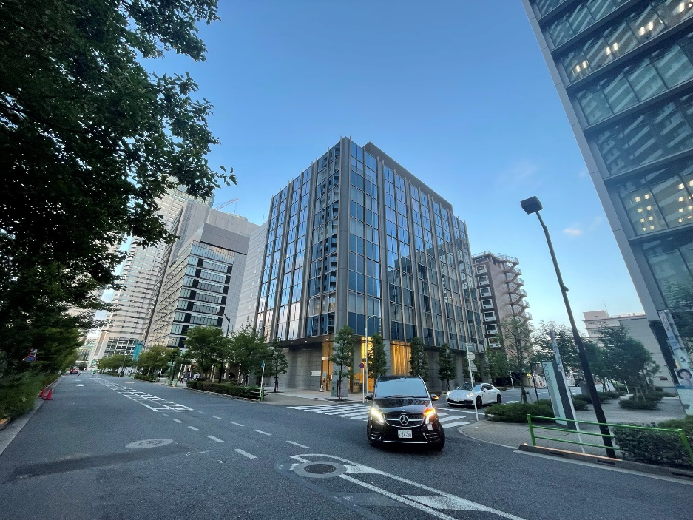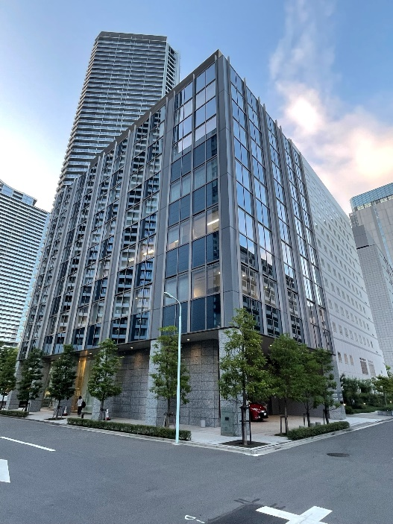

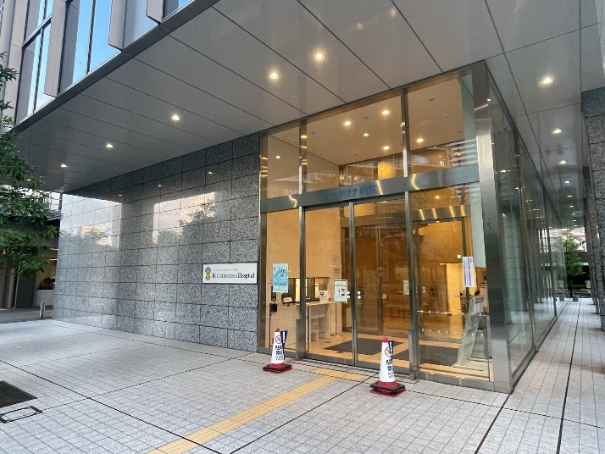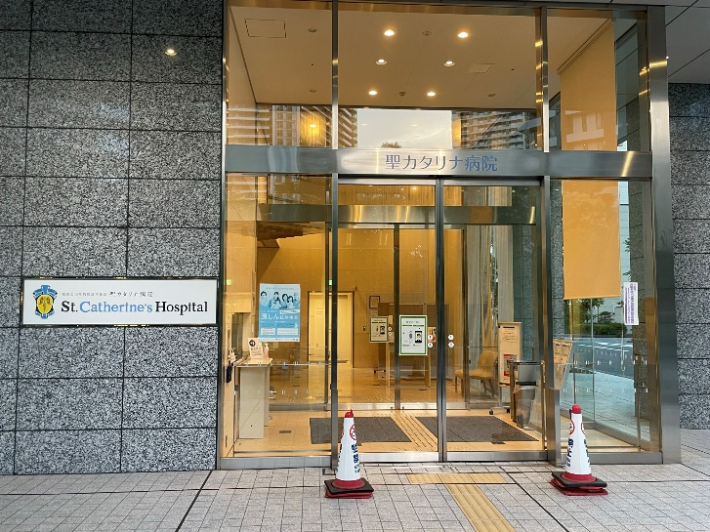

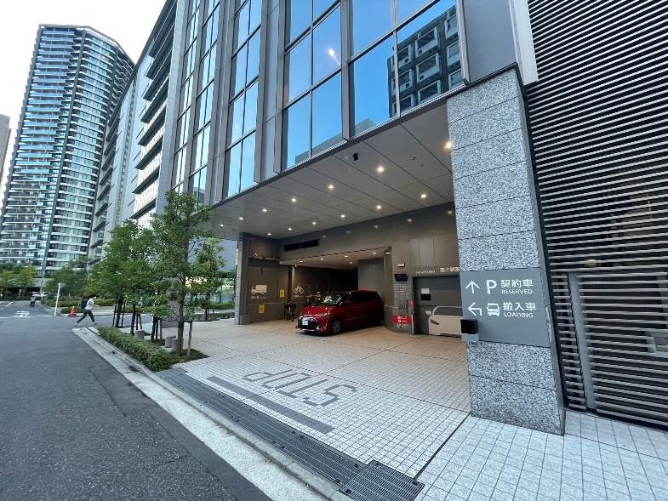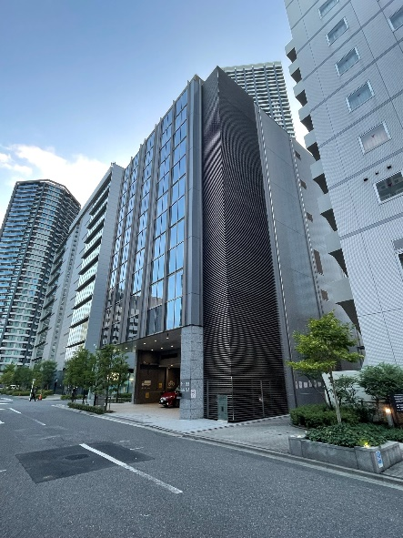

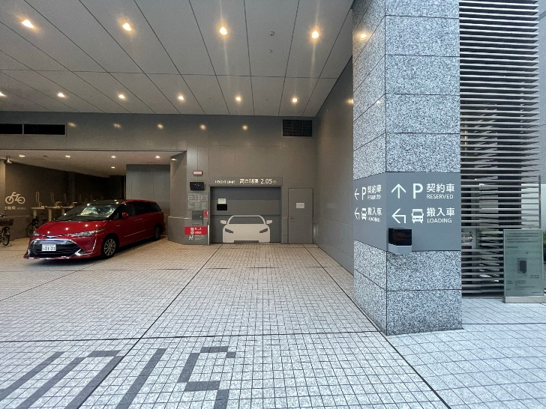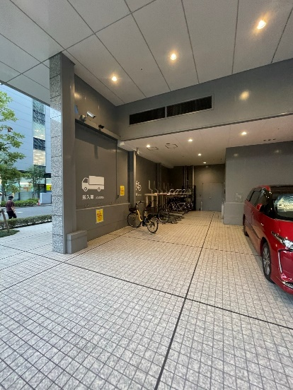

*Internal*

*1F reception area:*

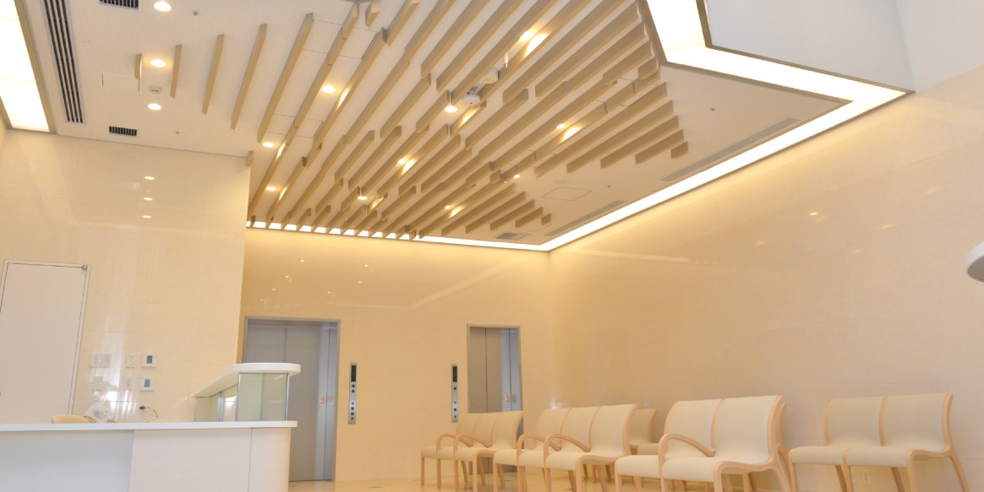

*2F waiting area:*

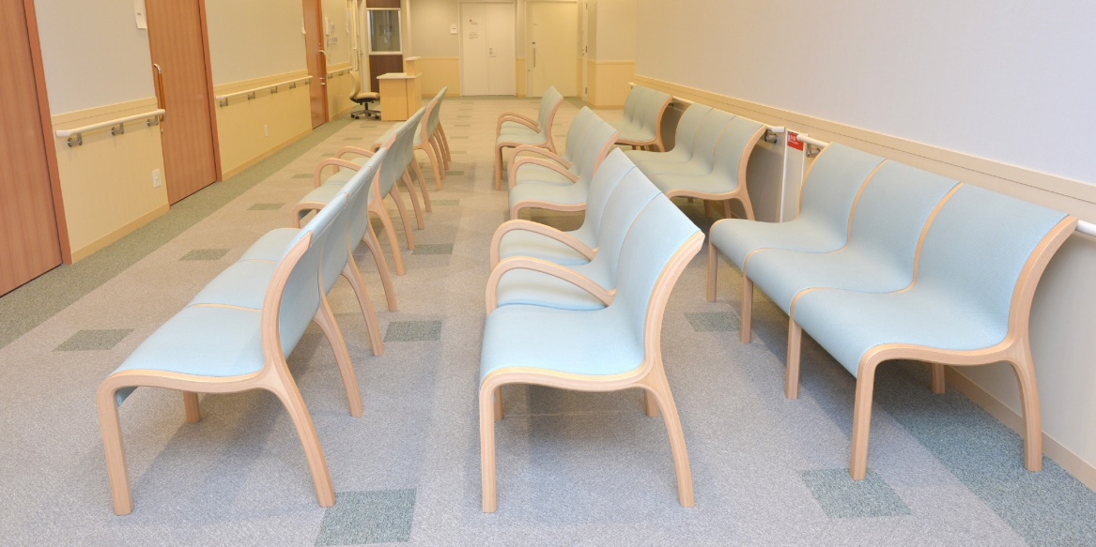

*4F semi-private room:*

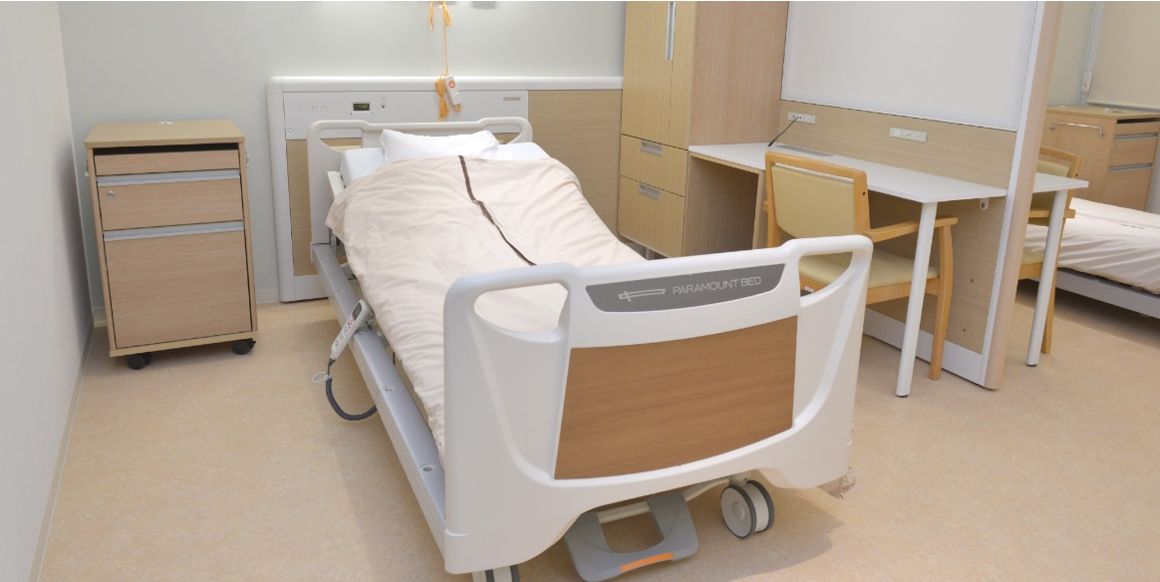

*Indicative private room:*

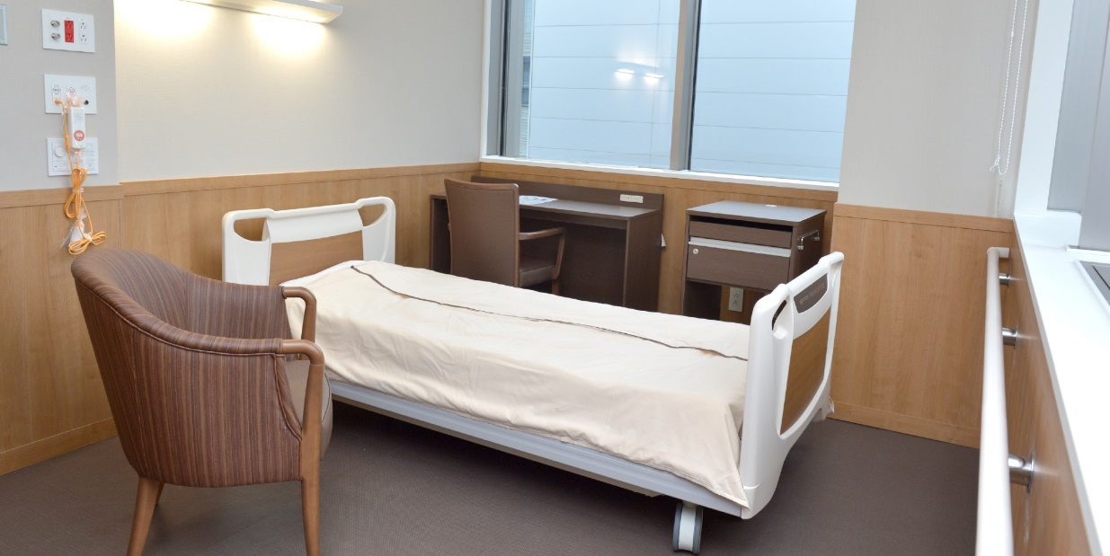

*Indicative private toilet:*

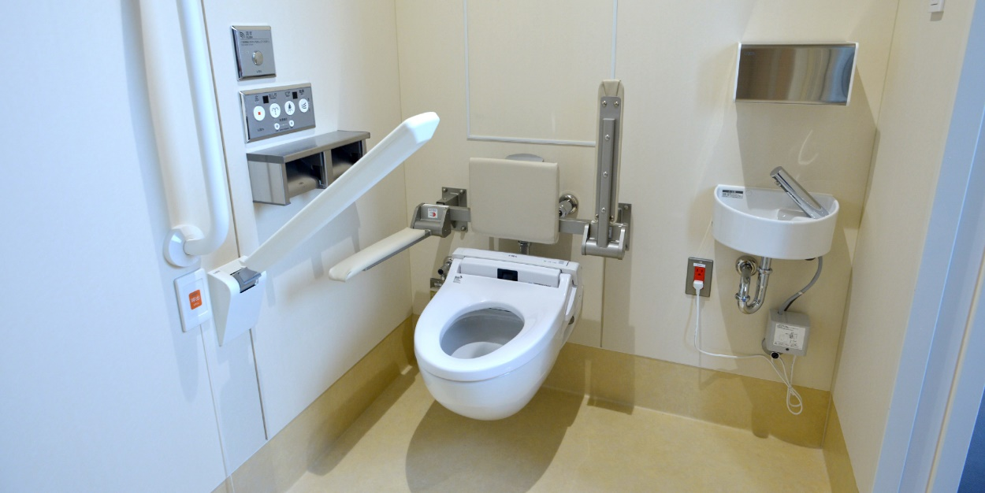

*Indicative day room:*

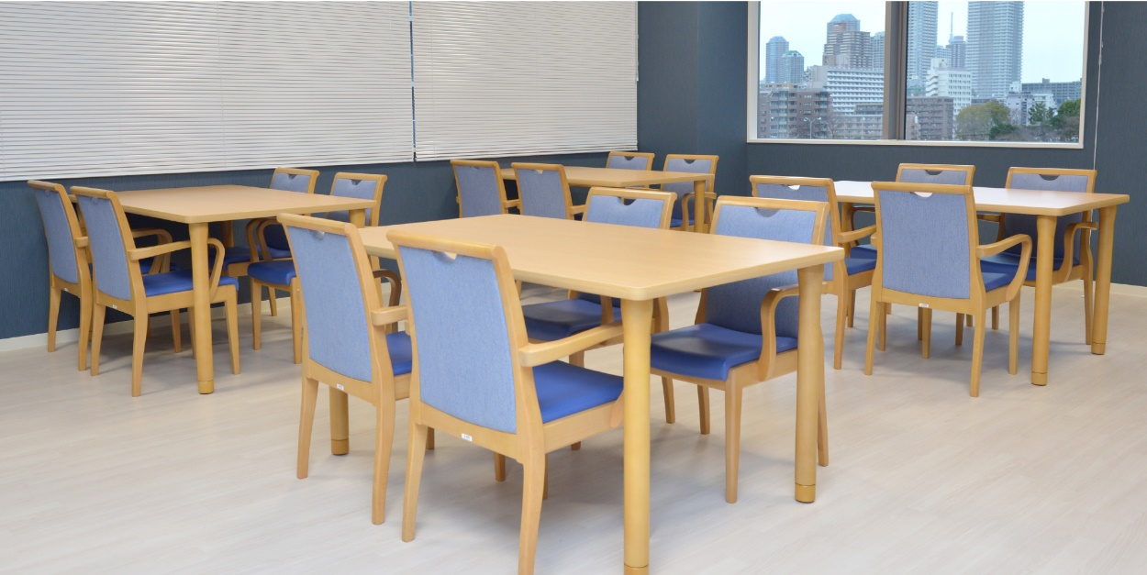

1. *Floor plans*

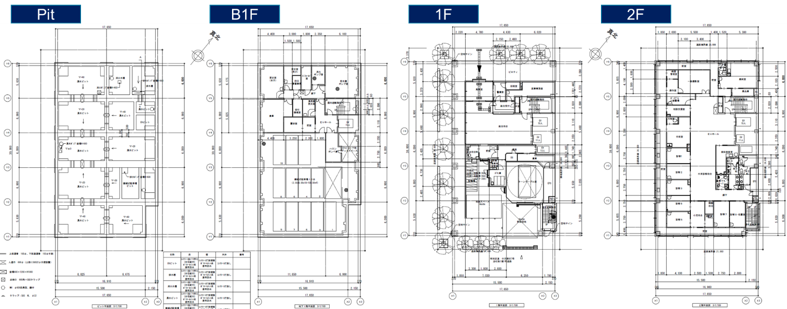

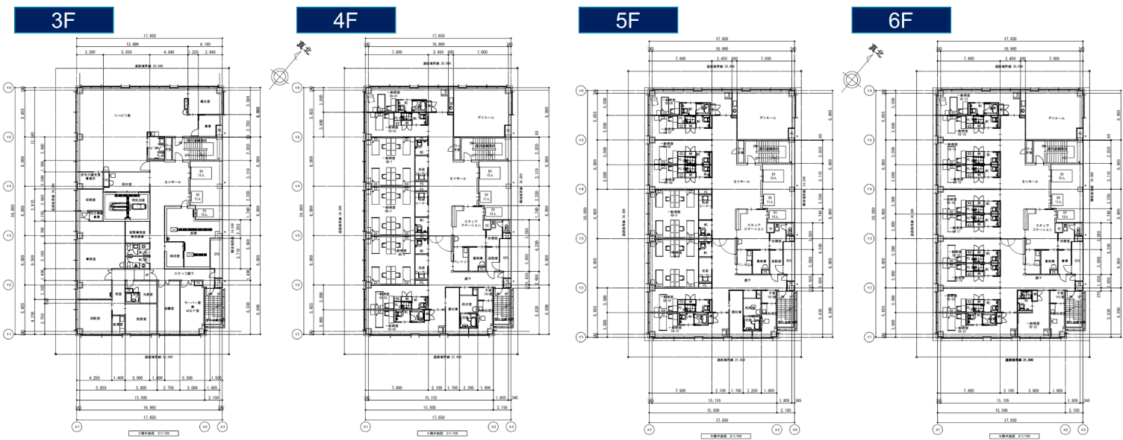

1. *UW Scenarios – Sensitivity Tables*

***Base case scenario – Fund-level returns (post tax, post-fees)***



***Downside scenario 1: +30bps on base rate – Fund-level returns (post tax, post-fees)***



***Downside scenario 2: worst-case; re-tenanting***

*As the tenant is under a fixed-term lease we do not anticipate for an early mid-term termination; moreover, there lease is backed by a full-term rental guarantee with a credit entity. However, we have constructed a downside, worst-case scenario assuming:*

* *Tenant vacating the premises mid-lease (Year 3)*
* *Excludes rent coverage from master-lease guarantor during downtime*
* *12 month downtime to re-lease property - multi-tenanted with medical and office tenants*
* *Medical and office tenant rent levels in-line with market (JPY16,500/tsubo & 16,000/tsubo)*
* *Usage of tenant security deposit to facilitate tenant reinstatement and partial office conversion*
* *Additional cap rate compression on exit cap of 30bps as a result of single tenant risk mitigation*
* *Conservative leasing incentives budgeted to cover re-tenanting*

***Worst-case scenario sensitivity – Fund-level returns (post tax, post-fees)***



1. *Transaction comparables*



*Map of transaction comparables*

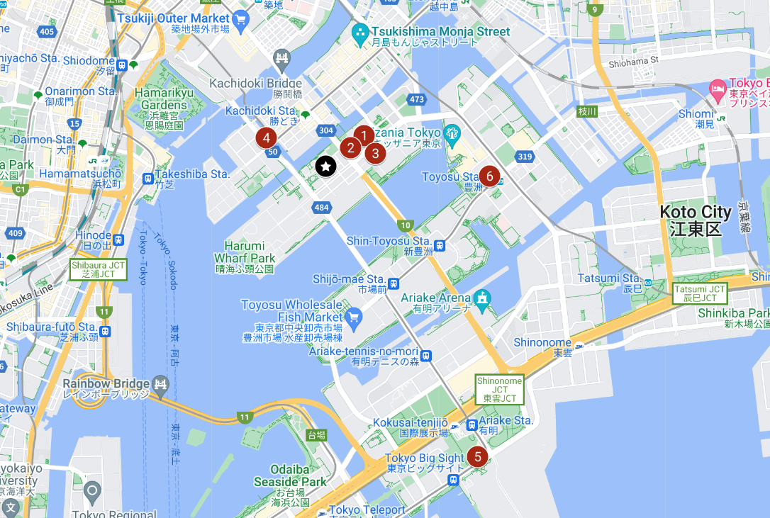

1. *Rental comparables*



1. *Area demographics*

*Chuo Ward - Tsukishima Area and Harumi Demographics*

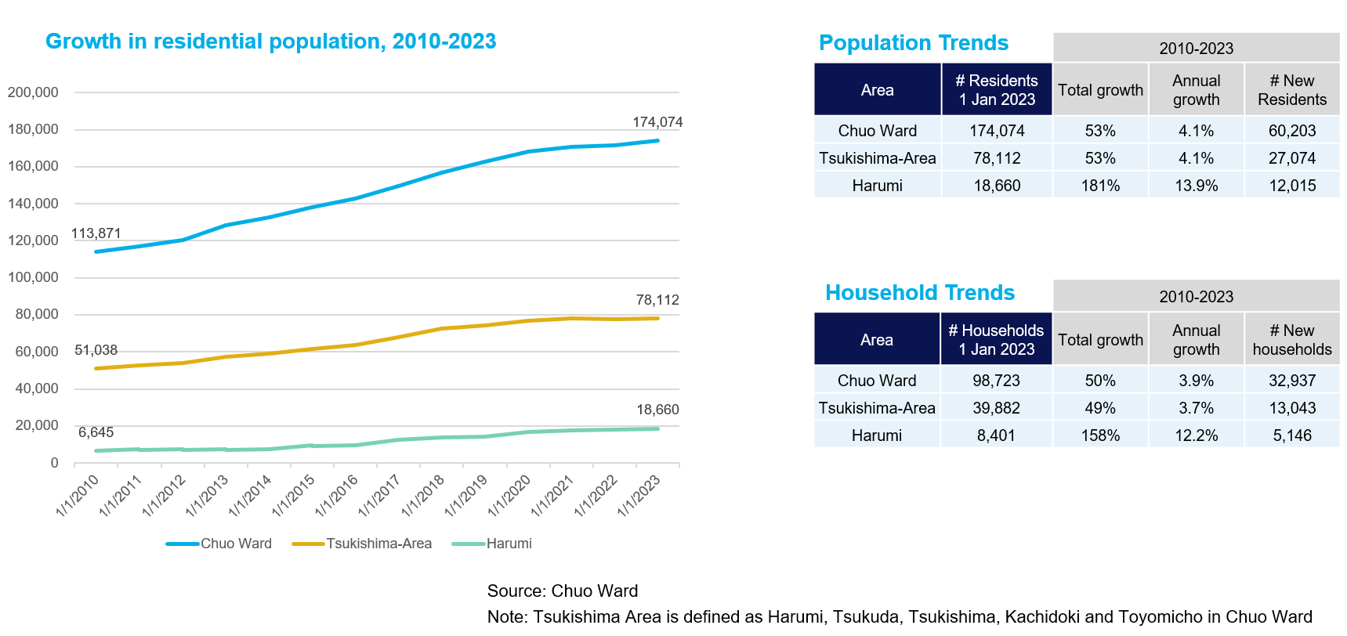

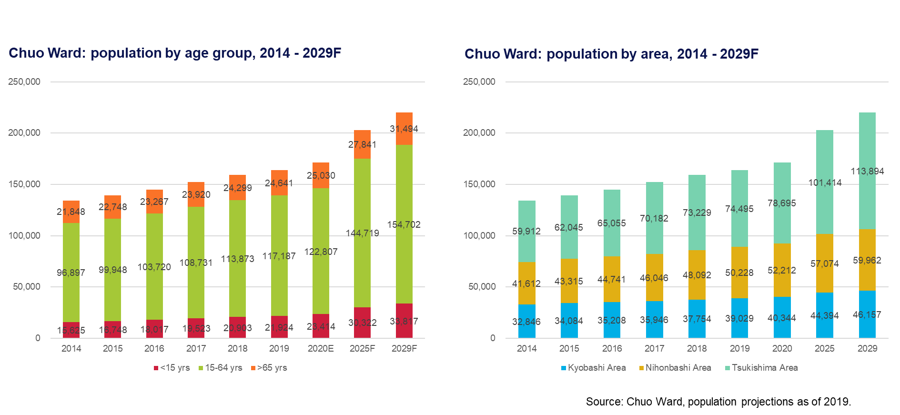

1. *Area overview*

